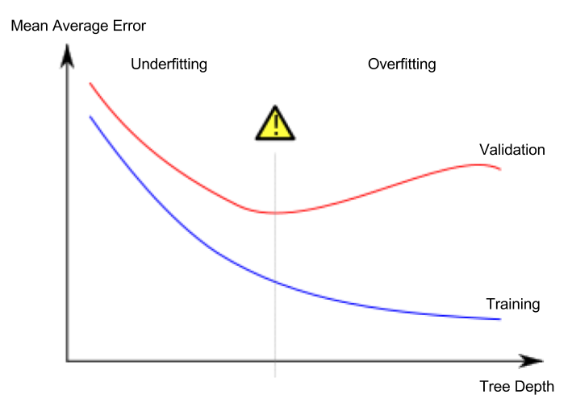

from sklearn.metrics import mean_absolute_error
from sklearn.tree import DecisionTreeRegressor

def get_mae(max_leaf_nodes, train_X, val_X, train_y, val_y):
model = DecisionTreeRegressor(max_leaf_nodes=max_leaf_nodes, random_state=0)
model.fit(train_X, train_y)
preds_val = model.predict(val_X)
mae = mean_absolute_error(val_y, preds_val)
return(mae)
# compare MAE with differing values of max_leaf_nodes
for max_leaf_nodes in [5, 50, 500, 5000]:
my_mae = get_mae(max_leaf_nodes, train_X, val_X, train_y, val_y)
print("Max leaf nodes: %d \t\t Mean Absolute Error: %d" %(max_leaf_nodes, my_mae))

Overfitting: capturing spurious patterns that won't recur in the future, leading to less accurate predictions, or
Underfitting: failing to capture relevant patterns, again leading to less accurate predictions.
The random forest uses many trees, and it makes a prediction by averaging the predictions of each component tree.
Decision tree
Random forest
XGBoost

Pipelines keep the data preprocessing and modeling clean and organized. Specifically, a pipeline bundles preprocessing and modeling steps so you can use the whole bundle as if it were a single step.

One Hot Encoding : Encode categorical integer features using a one-hot aka one-of-K scheme. (dummy variables)

